**BIOLOGY FOR ENGINEERS**

**LECTURE NOTES**

**CO1**

CO1 Interpret the buildings blocks of life by analyzing the elements, chemical bonding and macromolecules of living systems

CO5 Integrate the concepts of biology in solving complex engineering problems

|  |  |  |
| --- | --- | --- |
| Lectures | Topics | CO |
| 1 | Introducing the topic | 5 |
| 2 | Bioinspiration: Examples of bioinspiration models used in engineering. | 5 |
| 3 | Building blocks of life: Elements of life and their bonding ability, importance of carbon, elemental replacement | 1 |
| 4 | Different types of bonds and interactions in biological systems | 1 |
| 5 | Water and phospholipids as well as their importance in the survival of life | 1 |
| 6 | Macromolecules such as carbohydrates | 1 |
| 7 | Proteins, their structures | 1 |
| 8 | Enzymes | 1 |

**Lecture 1**

Introduction to the course

Purpose of Biology for Engineers

“As engineers, we are always looking into how to modify or improve an existing system. We must hold the key to combining the fields of engineering and biology, and this course is designed to provide a logical understanding about biology from an engineering perspective. So our aim is to understand the logical principles of biology, inspire the ideas from it to have a useful creativity in the engineering field”

**Lecture 2**

Bioinspiration: Examples of bioinspiration models used in engineering.

In this lecture we are trying to discuss responses for few fundamental questions:

1. Why engineers must look at living things? Or What is the logic of asking engineers to look at biological systems
2. How biology can solve complex engineering problems?
3. Does biology helps engineers for better creativity and problem solving??

Livings things improve existing form and designs. It changes according to the environmental changes. This happens through evolution. Living things sense as well as produce and respond to signals. Living things can repair by itself. It stores information. They can also transfer information. At the molecular level, livings creatures on earth are similar, but a small change in their organization has resulted in its diversity. Scientists consider nature as the best engineer, because its designs are the perfect ones - survival of the fittest.

(Discuss the examples shown in the video by Janine Benyus)

**LECTURE 3**

**Building blocks of life: Elements of life and their bonding ability, importance of carbon, elemental replacement**

Chemistry of life:

The atomic composition of the cell: H = 63%, O = 24% C = 10%, N = 1.4 %, P = 0.2 % & S = < 0.1%

Trace amount: Ca, Cl, K, Na, Mg, Mn, Fe, Se, I etc

Let us understand what an element is and where these elements related to life are present in the periodic table by simple pictures.

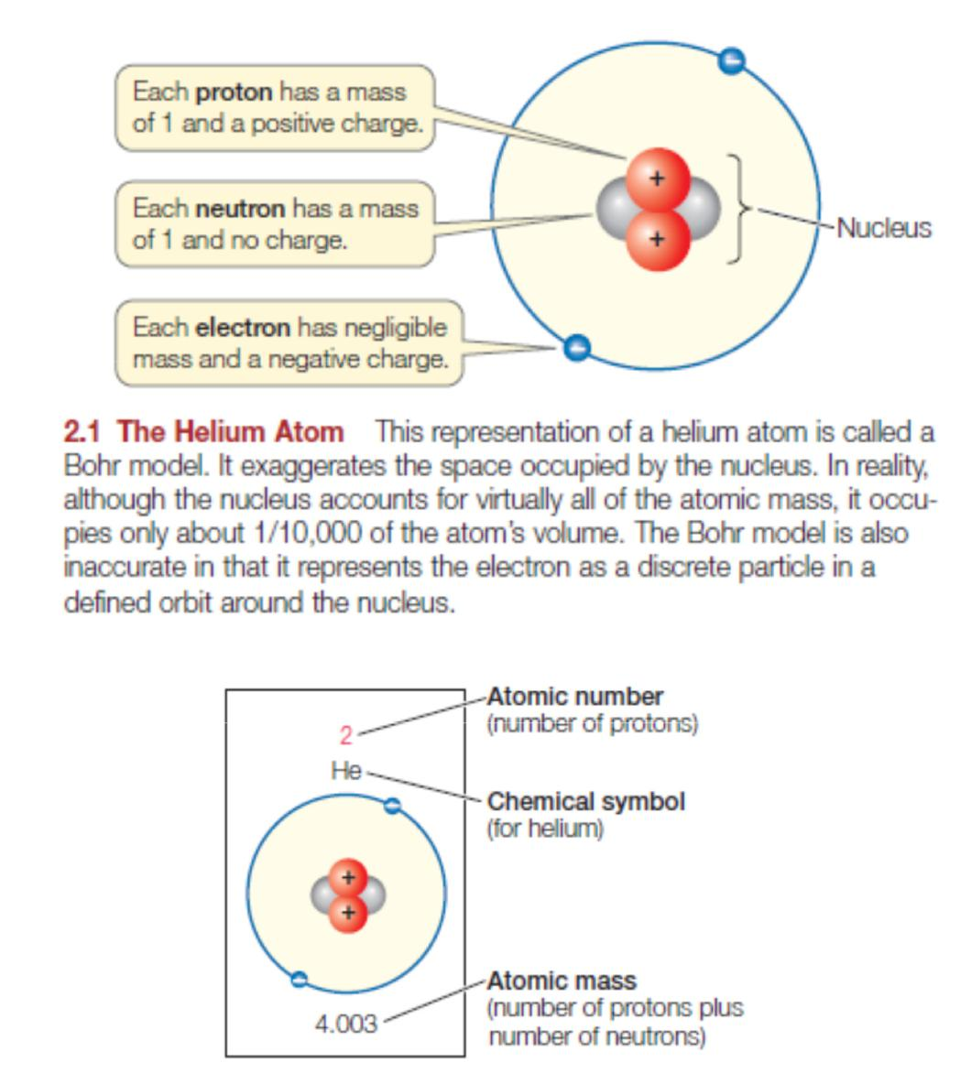

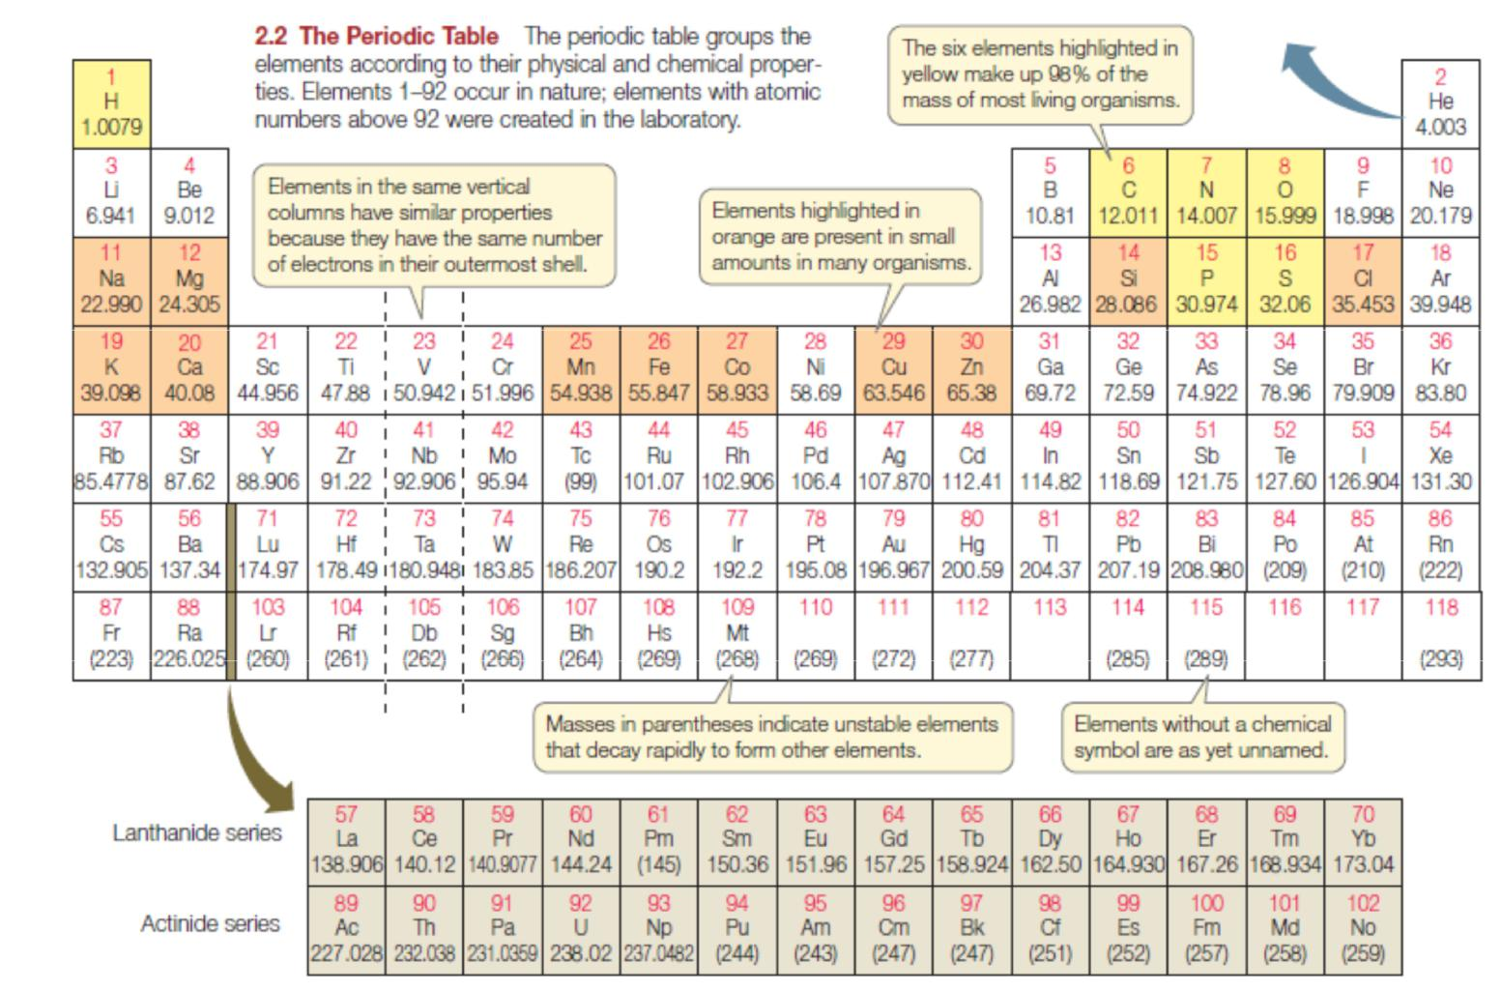

When we look at the composition of elements, C, N, O & H constitutes more than 95%. They are also lightest elements in the periodic table (As we go down in the periodic table, atomic number is going to increase so as atomic mass)

Suppose we want to design a moving machine like car what are the critical things we look for before selecting material to construct a body of the car? One of the criteria should be Materials used should not be heavy (fuel efficiency is going to decrease). The backbone element of life is carbon and carbon is the appropriate element to become a backbone element of life, since no element is present above carbon in periodic table which can have similar properties and lighter than carbon.

Important properties of these elements are their ability to form bond with other elements to form compounds/molecules. Let us see the molecular composition of the life. 80% is water & the dry weight of remaining 20% contains 50% protein, 15% carbohydrates, 10% lipids & fats & 15% nucleic acids.

Formation of these molecules and the interaction between these molecules depends on the chemical properties of the important six elements we mentioned it before. In this course, we just learn Chemistry to logically understand the structure and functions of Biomolecules and their interaction.

Two important properties we are concentrating in this course to understand the elements used in life are valency and electronegativity. The Valency of an atom is unpaired electron in the outer orbital of the shell. This gives an opportunity for the element to combine with other element.

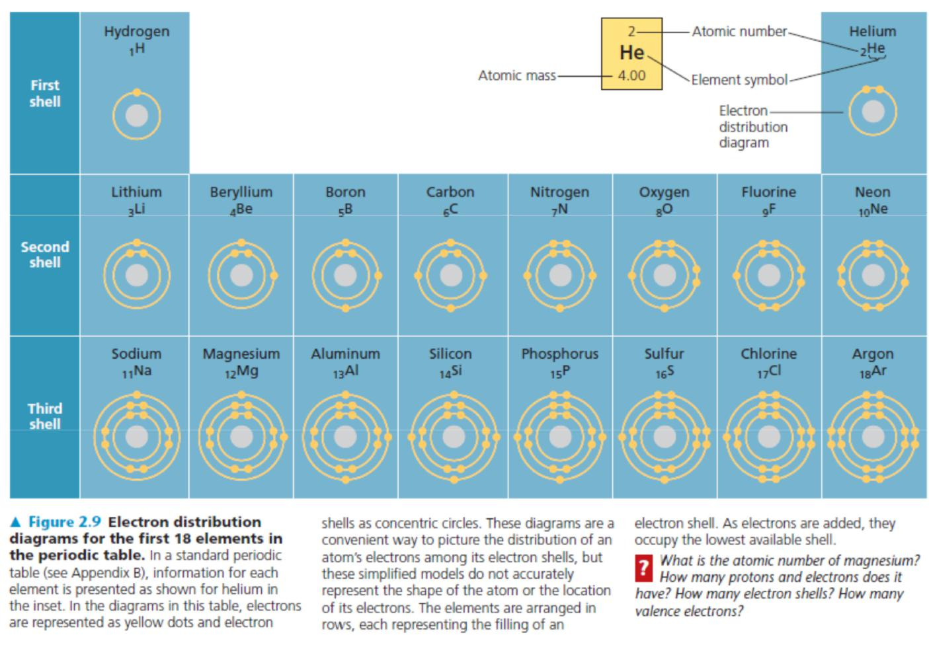

Valency of H = 1, C=4, 0 = 2, N = 3 or 4, P = 3 or 5 and S = 2 (As shown in the figure), 4, 6

Covalent Bond: sharing of a pair of valence electrons by two similar or dissimilar elements.

C−C single bond. Energy required to break them is equal to 80 Kcal/mol

C=C double bond (more energy is required to break them compared to single bond between them)

C≡C triple bond (more energy is required to break them compared to double bond)

Covalent bonds are very strong. Suppose if we compare covalent bond strength to say random energy fluctuation in daily life- random thermal fluctuations at room temperature are on the order of 0.6 kilocalories per mole. Covalent bonds are extremely stable, usually, unless something is attacking them and breaking them.

**LECTURE 4**

**Different types of bonds and interactions in biological systems**

Atoms in a molecule attract shared electrons in varying degrees, depending on the element. The attraction of a particular element for the electrons of a covalent bond is called its electronegativity. The more electronegative this element is, the more strongly it pulls shared electrons towards itself. If an element bonded to more electronegative element, the electrons of the bond are not shared equally therefore, There exists a polarity between them. This type of bond is called polar covalent bond. Such bonds vary in their polarity depending on the relative electronegativity of the two elements. For example the bond between the hydrogen atom and oxygen atom in water molecule is quite polar.

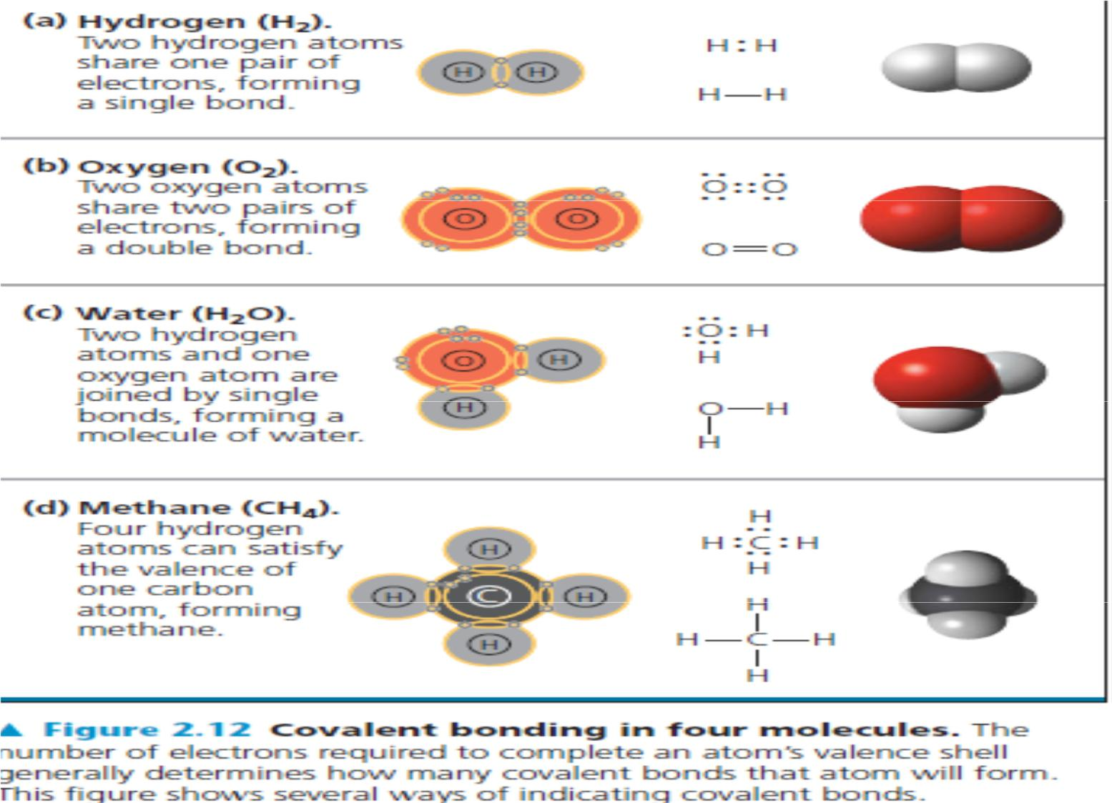

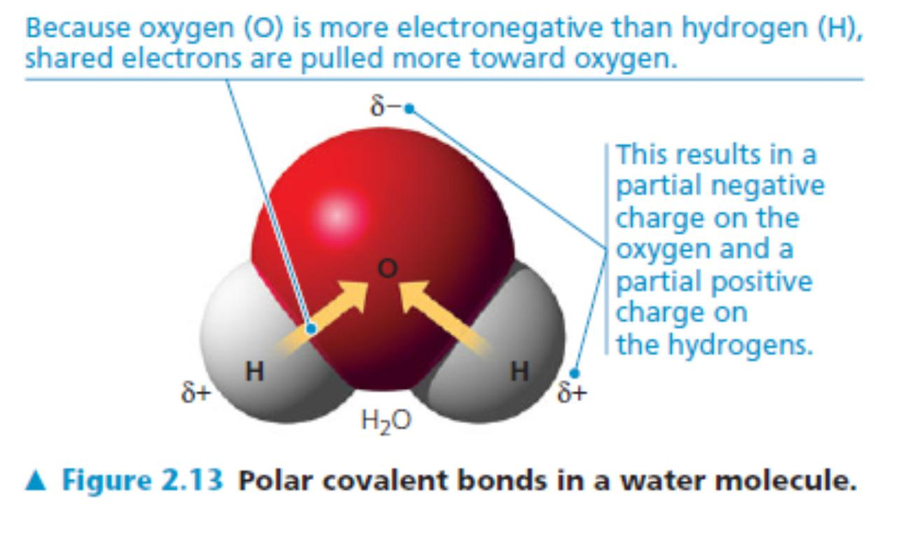

How do we know that polarity exist between two atoms of elements? What is the measuring way?

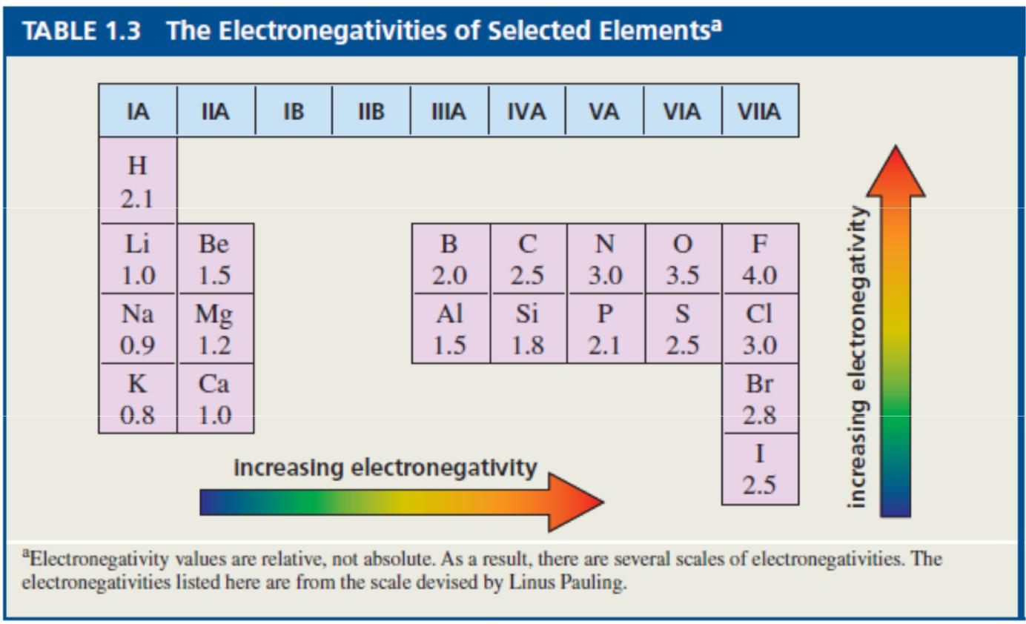

Please refer the figure above. Suppose if the difference in electronegativity between the two atoms is 0.5 and more, there exist polarity.

Example: carbon and hydrogen C-H the difference in electronegativity is 0.4 so it is non-polar. Carbon and oxygen C-O The difference is 1.0 therefore polarity exist.

Ionic Bond: transfer of electrons from one atom to another atom to form bond. The atom should form ions i.e. it should be in ionic state (positively charged or negatively charged) before it forms bond with another oppositely charged ion. The bonds are strong as long as it is not disturbed. If it is disturbed it becomes fragile. Ex: Once the water is added to NaCl, the ionic bond breaks.

LECTURE 5

**Water and phospholipids as well as their importance in the survival of life**

**Water and Phospholipid**

Life on earth began in water and evolved there for three billion years before spreading onto land. Although most of the water in liquid form, it is also in solid form and gaseous form. Water is the only solvent, it is present in all the three phases and interchange of the phases will enormously affect the life on the earth. We look into some of the important properties of water that make earth suitable for life.

**Polar covalent bonds in water molecules results in hydrogen bonding**

The hydrogen bonds form, break and re-form with great frequency. Each lasts only a few trillionths of a second, but the molecules are constantly forming new hydrogen bonds with a succession of partners. Therefore at any instant, all water molecules are hydrogen bonded to their neighbours.

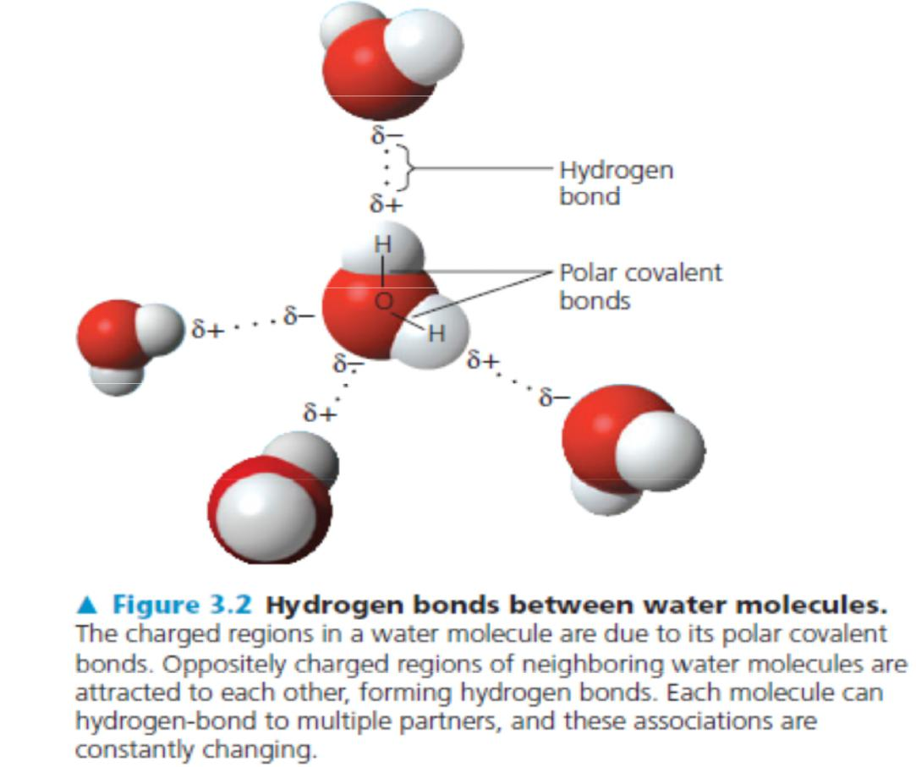

**Cohesive and adhesive properties of water**

Water molecules stay close to each other as a result of hydrogen bonding. Although the arrangement of molecules in a sample of liquid water is constantly changing, at any given moment many of the molecules are linked by multiple hydrogen bonds. These linkages make water more structured than most other liquids. Collectively, the hydrogen bonds hold the substance together, a phenomenon called cohesion.

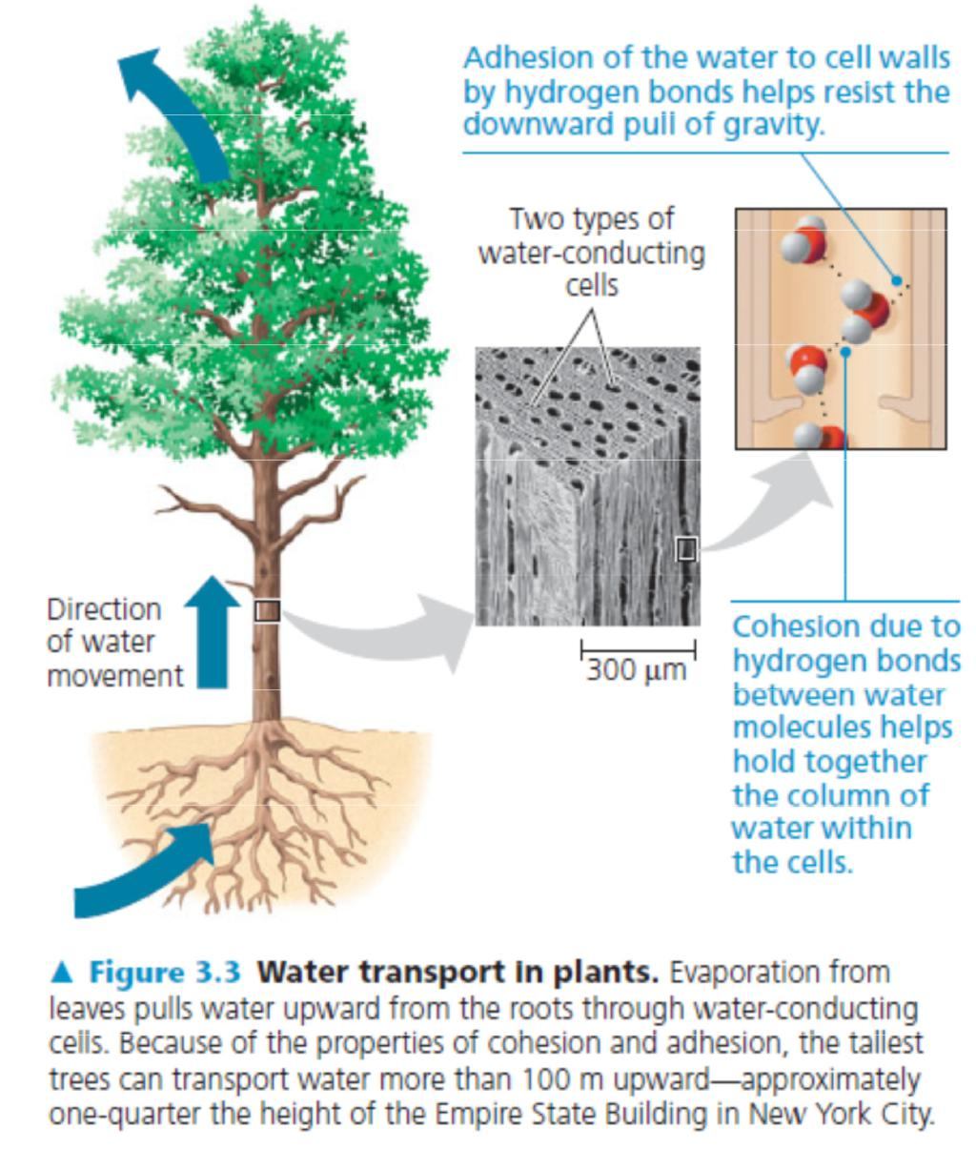

Adhesion, the clinging of one substance to another, also plays a role. Adhesion of water to cell walls by hydrogen bonds helps counter the downward pull of gravity

**Moderation of Temperature by Water**

Water moderates air temperature by absorbing heat from air that is warmer and releasing the stored heat to air that is cooler. Water is effective as a heat bank because it can absorb or release a relatively large amount of heat with only a slight change in its own temperature.How it can do that?

The ability of water to stabilize temperature stems from its relatively high specific heat. The specific heat of water is 1 calorie per gram and per degree Celsius, abbreviated as 1 cal/g_°C. Compared with most other substances, water has an unusually high specific heat. Because of the high specific heat of water relative to other materials, water will change its temperature less when it absorbs or loses a given amount of heat. We can trace water’s high specific heat, like many of its other properties, to hydrogenbonding. Heat must be absorbed in order to break hydrogen bonds; by the same token, heat is released when hydrogen bonds form. A calorie of heat causes a relatively small change in the temperature of water because much of the heat is used to disrupt hydrogen bonds before the water molecules can begin moving faster. And when the temperature of water drops slightly, many additional hydrogen bonds form, releasing a considerable amount of energy in the form of heat.

What is the relevance of water’s high specific heat to life on Earth? A large body of water can absorb and store a huge amount of heat from the sun in the daytime and during summer while warming up only a few degrees. At night and during winter, the gradually cooling water can warm the air. This is the reason coastal areas generally have milder climates than inland regions. The high specific heat of water also tends to stabilize ocean temperatures, creating a favorable environment for marine life. Thus, because of its high specific heat, the water that covers most of Earth keeps temperature fluctuations on land and in water within limits that permit life.

**Floating of Ice on Liquid Water**

Water is one of the few substances that are less dense as a solid than as a liquid. In other words, ice floats on liquid water. While other materials contract and become denser when they solidify, water expands. How it helps for life?

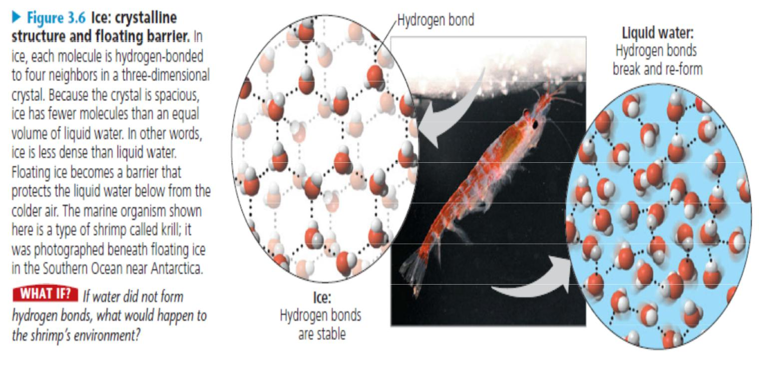

**Water: The Solvent of Life**

Water is a very good solvent. Many reactions take place in an organism. For almost all the reactions, water acts as a solvent.

**Possible Evolution of Life on Other Planets with Water**

Biologists who look for life elsewhere in the universe have concentrated their search on planets that might have water. To date, more than 200 planets have been found outside our solar system, and there is evidence for the presence of water vapor on one or two of them. In our own solar system, Mars has been most compelling to biologists as a focus of study. Like Earth, Mars has an ice cap at both poles.

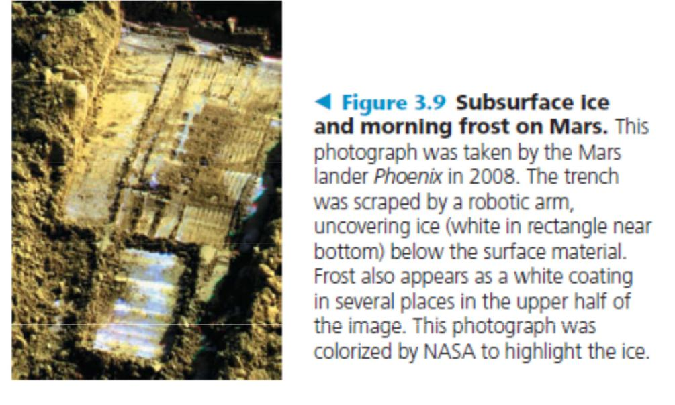

**Lipids and phospholipids:**

Lipids are hydrophobic molecules. The hydrophobic behavior of lipids is based on their molecular structure. Although they may have some polar bonds associated with oxygen, lipids consist mostly of hydrocarbon regions. Lipids are varied in form and function. They include waxes and certain pigments, but we will focus on the most biologically important types of lipids: fats & phospholipids.

A fatty acid has a long carbon skeleton, usually 16 or 18 carbon atoms in length. The carbon at one end of the skeleton is part of a carboxyl group, the functional group that gives these molecules the name fatty acid. The rest of the skeleton consists of a hydrocarbon chain. The relatively nonpolar C¬H bonds in the hydrocarbon chains of fatty acids are the reason fats are hydrophobic. Fats separate from water because the water molecules hydrogen bond to one another and exclude the fats. In making a fat, three fatty acid molecules are each joined to glycerol by an ester linkage, a bond between a hydroxyl group and a carboxyl group. The resulting fat, also called a triacylglycerol, thus consists of three fatty acids linked to one glycerol molecule.

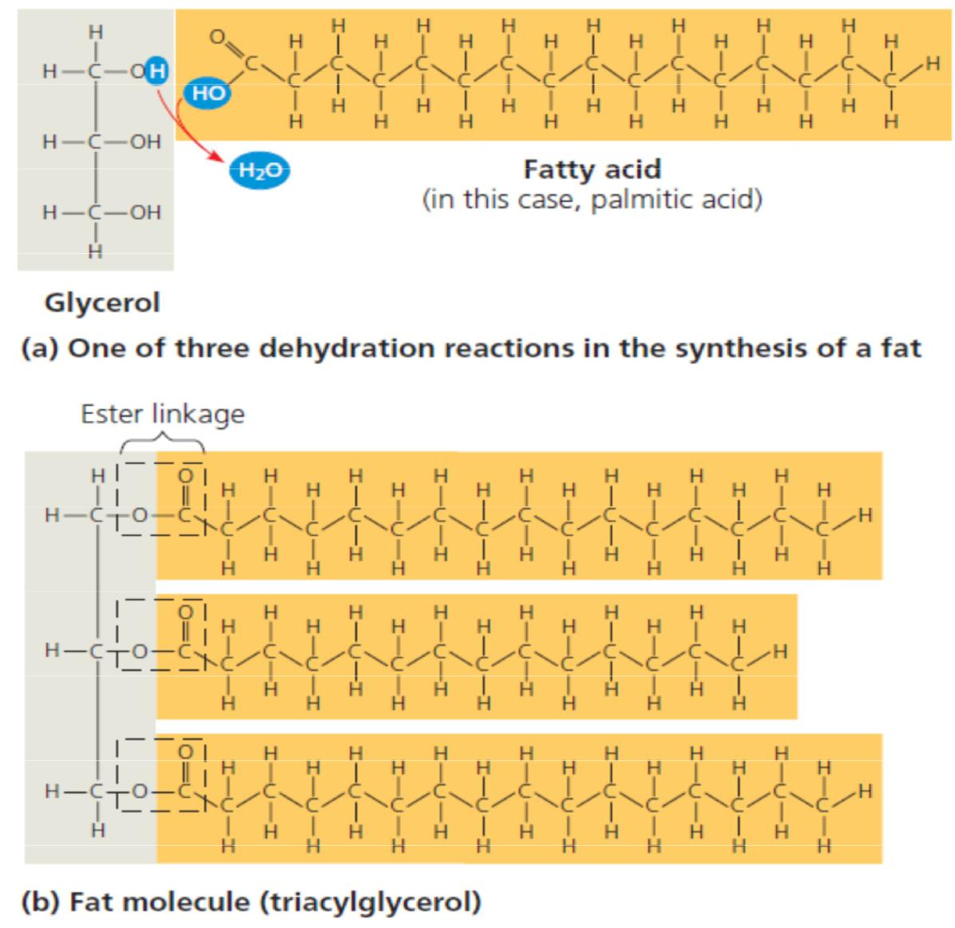

The terms saturated fats and unsaturated fats are commonly used in the context of nutrition. These terms refer to the structure of the hydrocarbon chains of the fatty acids. If there are no double bonds between carbon atoms composing a chain, then as many hydrogen atoms as possible are bonded to the carbon skeleton. Such a structure is said to be saturated with hydrogen, and the resulting fatty acid therefore called a saturated fatty acid. An unsaturated fatty acid has one or more double bonds, with one fewer hydrogen atom on each double-bonded carbon. Nearly all double bonds in naturally occurring fatty acids are cis double bonds, which cause a kink in the hydrocarbon chain wherever they occur

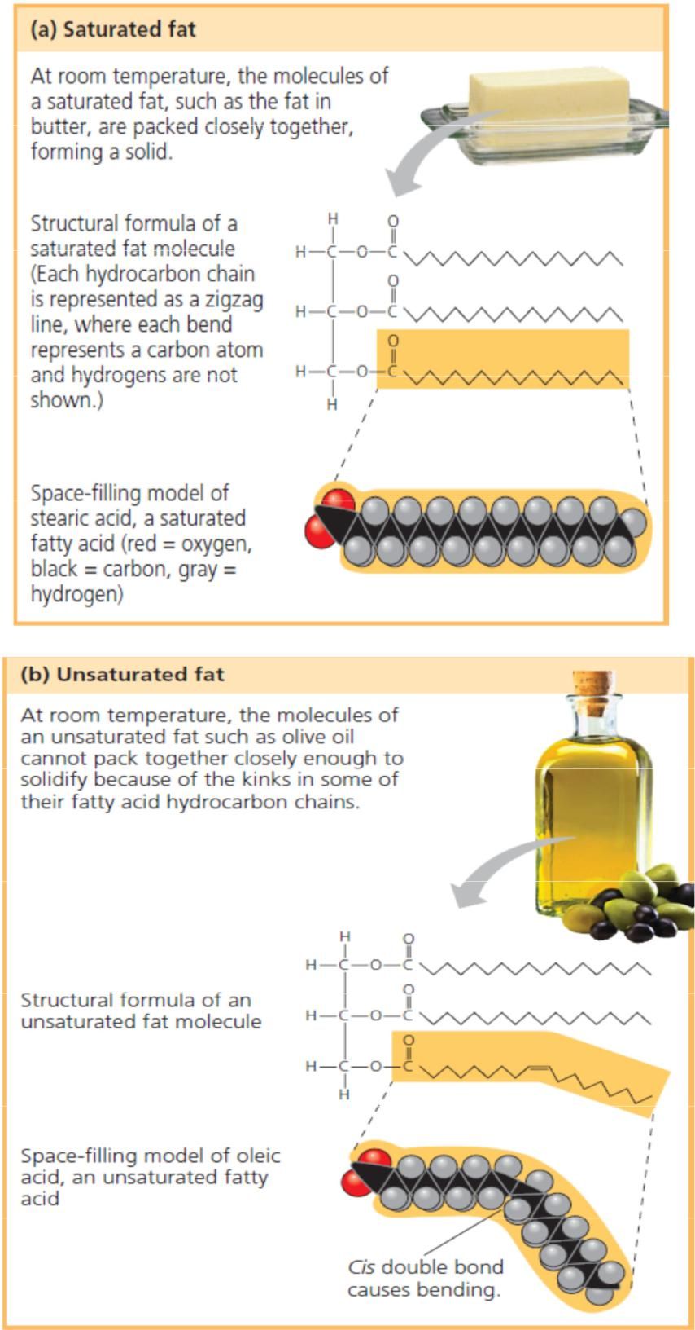

Phospholipids are essential for cells because they make up cell membranes. Phospholipid is similar to a fat molecule but has only two fatty acids attached to glycerol rather than three. The third hydroxyl group of glycerol is joined to a phosphate group, which has a negative electrical charge in the cell. Additional small molecules, which are usually charged or polar, can be linked to the phosphate group to form a variety of phospholipids. The two ends of phospholipids show different behaviour toward water. The hydrocarbon tails are hydrophobic and are excluded from water. However, the phosphate group and its attachments form a hydrophilic head that has an affinity for water. These strange behaviour molecules are called amphipathic molecules. When phospholipids are added to water, they self-assemble into double-layered structures called “bilayers,” shielding their hydrophobic portions from water. At the surface of a cell, phospholipids are arranged in a similar bilayer. The hydrophilic heads of the molecules are on the outside of the bilayer, in contact with the aqueous solutions inside and outside of the cell. The hydrophobic tails point toward the interior of the bilayer, away from the water. The phospholipid bilayer forms a boundary between the cell and its external environment; in fact, cells could not exist without phospholipids

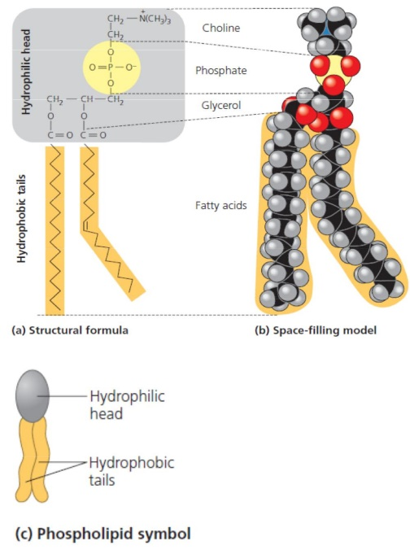

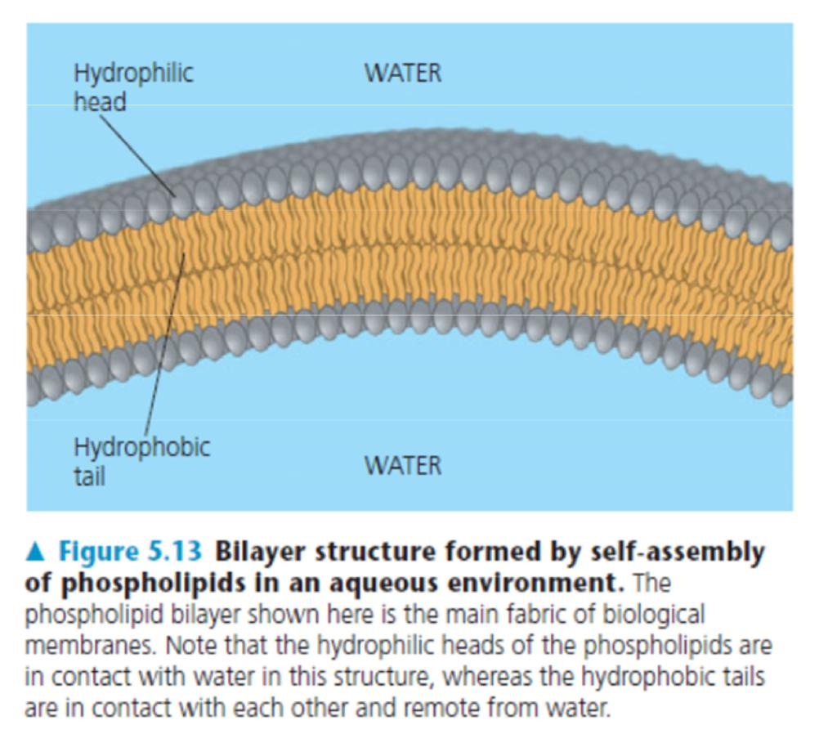

**Lecture 6**

**Carbohydrates**

Carbohydrates include both sugars and polymers of sugars. The simplest carbohydrates are the monosaccharides, or simple sugars; these are the monomers from which more complex carbohydrates are constructed. Disaccharides are double sugars, consisting of two monosaccharides joined by a covalent bond. Carbohydrates also include macromolecules called polysaccharides, polymers composed of many sugar building blocks.

Monosaccharides (from the Greek monos, single, and sacchar, sugar) generally have molecular formulas that are some multiple of the unit CH2O. Glucose (C6H12O6)(multiple of six), the most common monosaccharide, is of central importance in the chemistry of life. In the structure of glucose, we can see the trademarks of a sugar: The molecule has a carbonyl group (C_O) and multiple hydroxyl groups (— OH). Depending on the location of the carbonyl group, a sugar is either an aldose (aldehyde sugar) or a ketose (ketone sugar). Glucose, for example, is an aldose; fructose, an isomer of glucose, is a ketose. (Most names for sugars end in -ose.) Another criterion for classifying sugars is the size of the carbon skeleton, which ranges from three to seven carbons long. Glucose, fructose, and other sugars that have six carbons are called hexoses. Trioses (three-carbon sugars) and pentoses (five-carbon sugars) are also common.

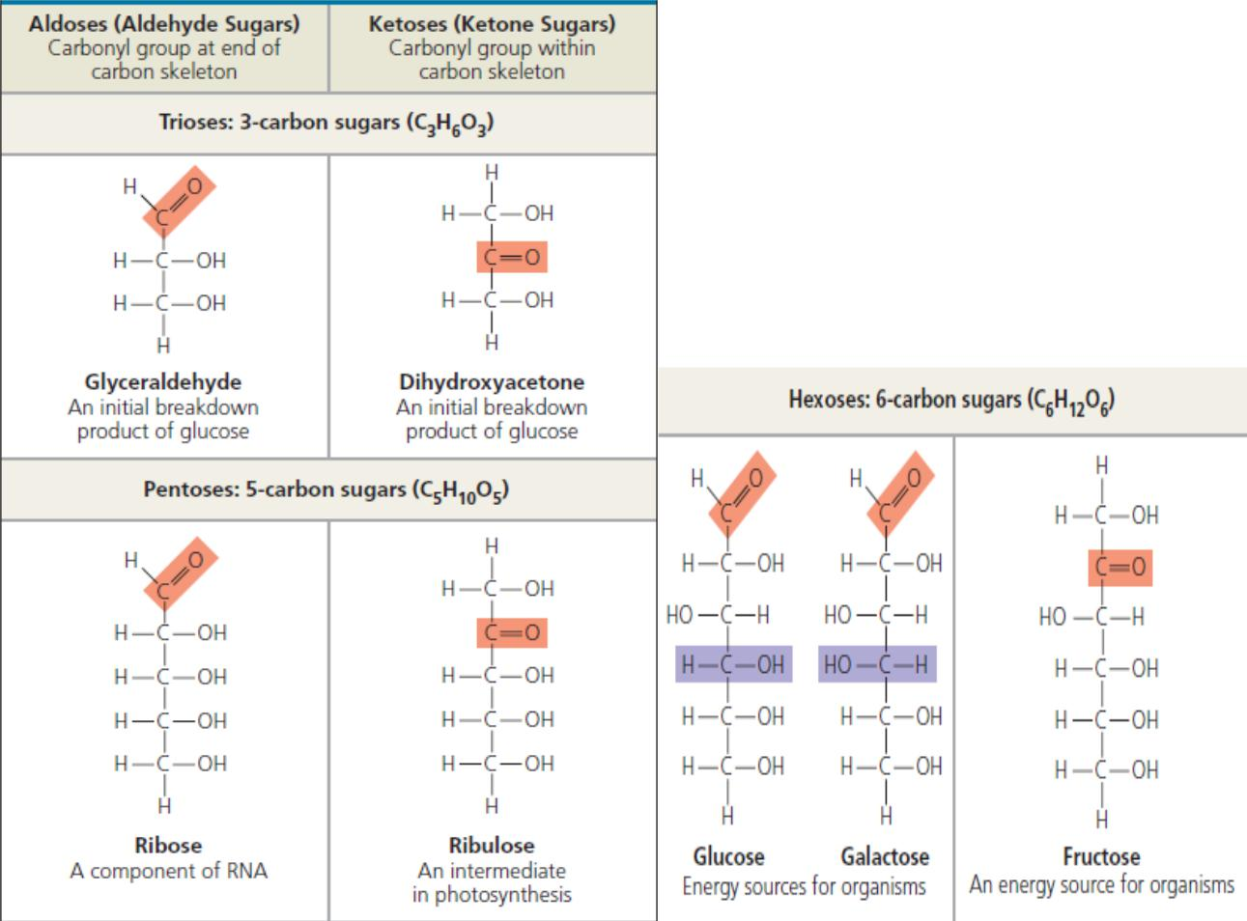

A disaccharide consists of two monosaccharides joined by a glycosidic linkage, a covalent bond formed between two monosaccharides by a dehydration reaction. For example, maltose is a disaccharide formed by the linking of two molecules of glucose. Also known as malt sugar, maltose is an ingredient used in brewing beer. The most prevalent disaccharide is sucrose, which is table sugar. Its two monomers are glucose and fructose. Plants generally transport carbohydrates from leaves to roots and other nonphotosynthetic organs in the form of sucrose. Lactose, the sugar present in milk, is another disaccharide, in this case a glucose molecule joined to a galactose molecule.

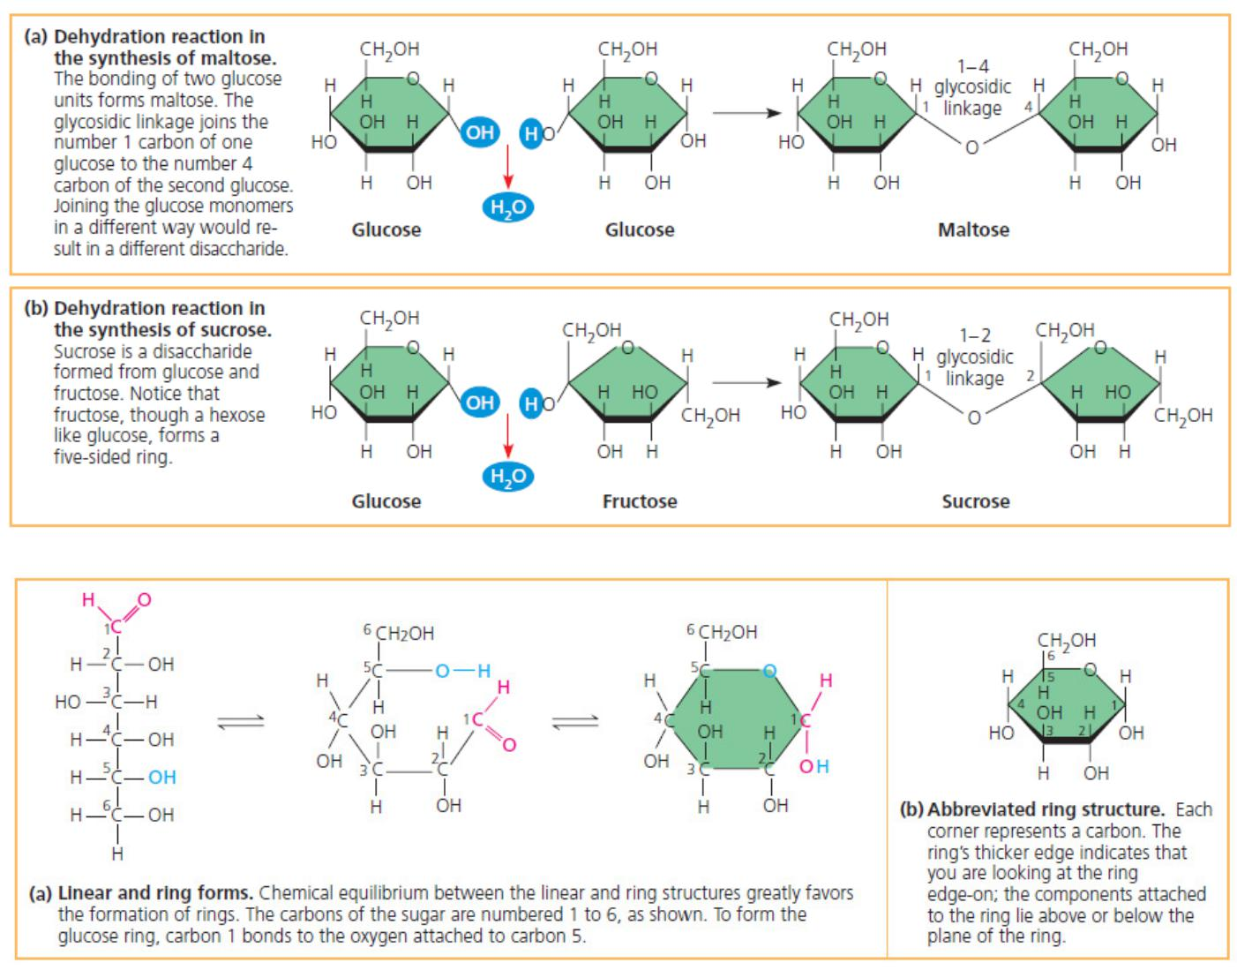

Polysaccharides are macromolecules, polymers with a few hundred to a few thousand monosaccharides joined by glycosidic linkages. Some polysaccharides serve as storage material, hydrolyzed as needed to provide sugar for cells. Other polysaccharides serve as building material for structures that protect the cell or the whole organism. The architecture and function of a polysaccharide are determined by its sugar monomers and by the positions of its glycosidic linkages.

Both plants and animals store sugars for later use in the form of storage polysaccharides. Plants store starch, a polymer of glucose monomers, as granules within cellular structures known as plastids, which include chloroplasts. Synthesizing starch enables the plant to stockpile surplus glucose. Because glucose is a major cellular fuel, starch represents stored energy. The sugar can later be withdrawn from this carbohydrate “bank” by hydrolysis, which breaks the bonds between the glucose monomers. Most animals, including humans, also have enzymes that can hydrolyze plant starch, making glucose available as a nutrient for cells. Potato tubers and grains—the fruits of wheat, maize (corn), rice, and other grasses—are the major sources of starch in the human diet.

Most of the glucose monomers in starch are joined by 1–4 linkages (number 1 carbon to number 4 carbon), like the glucose units in maltose. The simplest form of starch, amylose, is unbranched. Amylopectin, a more complex starch, is a branched polymer with 1–6 linkages at the branch points. Animals store a polysaccharide called glycogen, a polymer of glucose that is like amylopectin but more extensively branched. Humans and other vertebrates store glycogen mainly in liver and muscle cells. Hydrolysis of glycogen in these cells releases glucose when the demand for sugar increases.

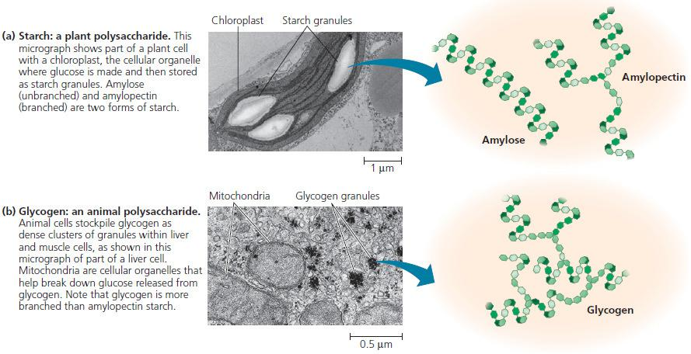

Structural Polysaccharides

Organisms build strong materials from structural polysaccharides. For example, the polysaccharide called cellulose is a major component of the tough walls that enclose plant cells. On a global scale, plants produce almost 1014 kg (100 billion tons) of cellulose per year; it is the most abundant organic compound on Earth. Like starch, cellulose is a polymer of glucose, but the glycosidic linkages in these two polymers differ. The difference is based on the fact that there are actually two slightly different ring structures for glucose. When glucose forms a ring, the hydroxyl group attached to the number 1 carbon is positioned either below or above the plane of the ring. These two ring forms for glucose are called alpha (α) and beta (β), respectively. In starch, all the glucose monomers are in the α configuration. The glucose monomers of cellulose are all in the β configuration, making every glucose monomer “upside down” with respect to its neighbors.

The differing glycosidic linkages in starch and cellulose give the two molecules distinct three-dimensional shapes. Whereas certain starch molecules are largely helical, a cellulose molecule is straight. Cellulose is never branched, and some hydroxyl groups on its glucose monomers are free to hydrogen-bond with the hydroxyls of other cellulose molecules lying parallel to it. In plant cell walls, parallel cellulose molecules held together in this way are grouped into units called microfibrils. These cable-like microfibrils are a strong building material for plants and an important substance for humans because cellulose is the major constituent of paper and the only component of cotton.

Enzymes that digest starch by hydrolyzing its α linkages are unable to hydrolyze the β linkages of cellulose because of the distinctly different shapes of these two molecules. In fact, few organisms possess enzymes that can digest cellulose. Animals, including humans, do not; the cellulose in our food passes through the digestive tract and is eliminated with the feces. Along the way, the cellulose abrades the wall of the digestive tract and stimulates the lining to secrete mucus, which aids in the smooth passage of food through the tract. Thus, although cellulose is not a nutrient for humans, it is an important part of a healthful diet. Most fresh fruits, vegetables, and whole grains are rich in cellulose. On food packages, “insoluble fiber” refers mainly to cellulose.

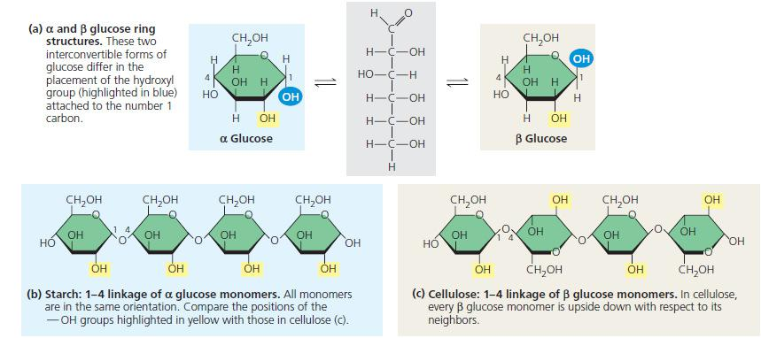

Some microorganisms can digest cellulose, breaking it down into glucose monomers. A cow harbors cellulose digesting prokaryotes and protists in its stomach. These microbes hydrolyze the cellulose of hay and grass and convert the glucose to other compounds that nourish the cow. Similarly, a termite, which is unable to digest cellulose by itself, has prokaryotes or protists living in its gut that can make a meal of wood.

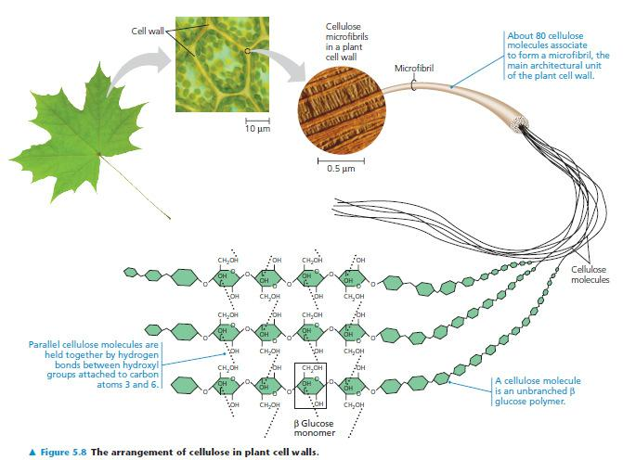

**Lecture 7**

**Proteins and their structures**

Proteins are the most abundant biological macromolecules, occurring in all parts of the cell. Proteins also occur in great variety; thousands of different kinds, ranging in size from relatively small peptides to huge polymers with molecular weights in millions. Nearly every dynamic function of a living being depends on proteins. In fact, the importance of proteins is underscored by their name, which comes from the Greek word *proteios*, meaning “first,” or “primary.” Proteins account for more than 50% of the dry mass of most cells, and they are instrumental in almost everything the organism does. Some proteins speed up chemical reactions, while others play a role in defense, storage, transport, cellular communication, movement, or structural support.

The basic building blocks of proteins are amino acids. Twenty different amino acids are commonly found in proteins. All 20 of the common amino acids are α-amino acids. They have a carboxyl group and an amino group bonded to the same carbon atom (αcarbon). They differ from each other in their side chains, or **R groups,** which vary in structure, size, and electric charge, and which influence the solubility of the amino acids in water. The common amino acids of proteins have been assigned three-letter abbreviations and one-letter symbols, which are used as shorthand to indicate the composition and sequence of amino acids polymerized in proteins.

The **primary structure** of a protein is simply the linear arrangement, or *sequence,* of the amino acid residues that compose it. Many terms are used to denote the chains formed by the polymerization of amino acids. A short chain of amino acids linked by peptide bonds and having a defined sequence is called a **peptide;** longer chains are referred to as **polypeptides.** Peptides generally contain less than 20–30 amino acid residues, whereas polypeptides contain as many as 4000 residues. We generally reserve the term **protein** for a polypeptide (or for a complex of polypeptides) that has a well-defined three-dimensional structure.





**Secondary structure**, are the result of hydrogen bonds between the repeating constituents of the polypeptide backbone (not the amino acid side chains). Within the backbone, the oxygen atoms have a partial negative charge, and the hydrogen atoms attached to the nitrogen have a partial positive charge; therefore, hydrogen bonds can form between these atoms. Individually, these hydrogen bonds are weak, but because they are repeated many times over a relatively long region of the polypeptide chain, they can support a particular shape for that part of the protein. One such secondary structure is the α- **helix**, a delicate coil held together by hydrogen bonding between every fourth amino acid. The other main type of secondary structure is the β- **pleated** **sheet**. In this structure two or more strands of the polypeptide chain lying side by side (called β strands) are connected by hydrogen bonds between parts of the two parallel polypeptide backbones.



**Turns** Composed of three or four residues, turns are located on the surface of a protein, forming sharp bends that redirect the polypeptide backbone back toward the interior. These short, U-shaped secondary structures are stabilized by a hydrogen bond between their end residues. Glycine and proline are commonly present in turns. The lack of a large side chain in glycine and the presence of a built-in bend in proline allow the polypeptide backbone to fold into a tight U shape. Turns allow large proteins to fold into highly compact structures. A polypeptide backbone also may contain longer bends, or *loops.* In contrast with turns, which exhibit just a few well-defined structures, loops can be formed in many different ways.

**Tertiary structure** is the overall shape of a polypeptide resulting from interactions between the side chains (R groups) of various amino acids. One type of interaction that contributes to tertiary structure is—somewhat misleadingly—called a **hydrophobic interaction**. As a polypeptide folds into its functional shape, amino acids with hydrophobic (nonpolar) side chains usually end up in clusters at the core of the protein, out of contact with water. Thus, a “hydrophobic interaction” is actually caused by the exclusion of nonpolar substances by water molecules. Once nonpolar amino acid side chains are close together, van der Waals interactions help hold them together. Meanwhile, hydrogen bonds between polar side chains and ionic bonds between positively and negatively charged side chains also help stabilize tertiary structure. These are all weak interactions in the aqueous cellular environment, but their cumulative effect helps give the protein a unique shape. Covalent bonds called **disulfide bridges** may further reinforce the shape of a protein. Disulfide bridges form where two cysteine monomers, which have sulfhydryl groups (¬SH) on their side chains, are brought close together by the folding of the protein. The sulfur of one cysteine bonds to the sulfur of the second, and the disulfide bridge (¬S¬S¬) rivets parts of the protein together. All of these different kinds of interactions can contribute to the tertiary structure of a protein.



 **Tertiary Structure of a Protein.**

**Quaternary structure** is the overall protein structure that results from the aggregation of these polypeptide subunits. Example: collagen, which is a fibrous protein that has three identical helical polypeptides intertwined into a larger triple helix, giving the long fibers great strength. This suits collagen fibers to their function as the girders of connective tissue in skin, bone, tendons, ligaments, and other body parts. Collagen accounts for 40% of the protein in a human body. Hemoglobin, the oxygen-binding protein of red blood cells is another example of a globular protein with quaternary structure. It consists of four polypeptide subunits, two of one kind (α) and two of another kind (β). Both α and β subunits consist primarily of α-helical secondary structure. Each subunit has a nonpolypeptide component, called heme, with an iron atom that binds oxygen.





**Lecture 8**

**Enzymes**

